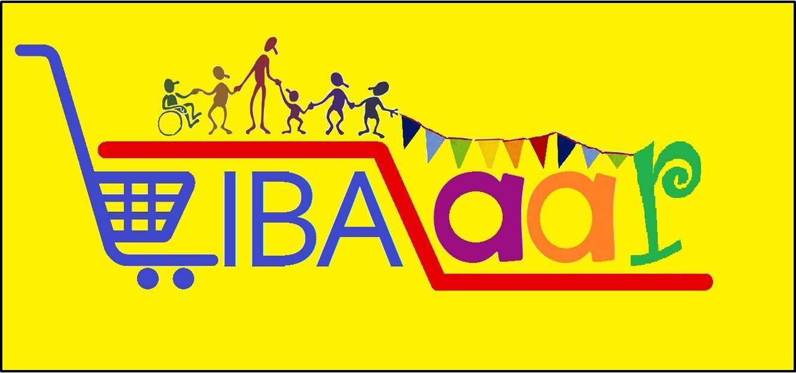

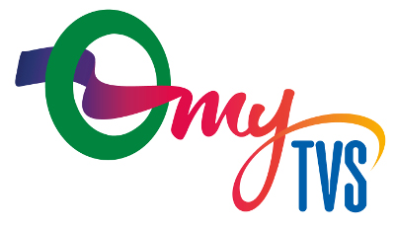

**LIBAZAAR ‘17 – MARKET RESEARCH REPORT FOR MY TVS**

CONTENTS-

INDYSTRY ANALYSIS 3

THE SERVICING WORLD 3

SECONDARY RESEARCH DATA: 3

COMPANY PROFILE: 4

My TVS’s Services: 5

MY TVS – DIFFERENTIATION: 5

RESEARCH: 6

PROBLEM STATEMENT: 6

QUESTIONNAIRE: 6

GAME FORMULATION: 7

DATA COLLECTION: 11

ANALYSIS: 11

2 SAMPLE T-TESTS 11

HYPOTHESIS 1: 11

HYPOTHESIS 2: 11

SUMMARY: 13

CONCLUSION: 18

# INDYSTRY ANALYSIS

India’s car servicing industry is slated to be a Rs 33,000-crore business by 2020, up from Rs 20,000 crore now, and multi-brand servicing networks expect to grab at least eight per cent of the business by then.

# THE SERVICING WORLD

* **Rs 20,000 cr** is the car-servicing industry size in India
* **46%** organised service centres are there
* **53%** unorganised players
* **1%**multi-brand organised servicing player
* **Rs 33,000 cr** is the estimated growth of industry by 2020
* **8%**is the rise of shares of multi-brand organised servicing players expected to be by 2020
* **2.5**is the no of mechanical services per year needed by each car on an average
* **0.25**accident service per year needed by each car
* **30 mn** cars on Indian road
* **28 mn** cars are road-worthy
* **5 mn**cars in warranty
* **23.6 mn**off-warranty cars need total 65 mn services every year

My TVS’s closest competitor**,** Mahindra First Choice Services, part of the Mahindra Group's aftermarket division, plans to garner 50 per cent share of the multi-brand service industry by 2020. However My TVS’s intent to take its count of outlets to 500 by 2018 from 100 now, will reap benefits.

# SECONDARY RESEARCH DATA:

* “Nearly 46 per cent of Indian cars are now serviced by service centres, 53 per cent by the unorganised sector, and only one per cent by multi-brand service centres”. **The challenge lies in converting customers servicing their cars in the unorganized sector to move towards multi brand car servicing units.**
* Each of the 23.6 million off-warranty cars on Indian roads needs 2.5 services and 0.25 repairs a year, adding up to 65 million trips to the workshop. At an average cost of Rs 3,500 for a service and Rs 5,000 for repairs, the size of the car service industry is just above Rs 20,000 crore.
* The post warranty vehicle (>4 years) service market was mainly captured by small independent garages.
* It is noted that close to 65% of the consumers break their connection with authorised workshop post warranty.

# COMPANY PROFILE:

TVS was established in 1911 by Shri. T V Sundram Iyengar as a trading company. It has now become India's largest industrial house. Today, there are over 50 companies in TVS Group, employing more than 50,000 people worldwide and with a turnover in excess of USD 6 billion.

With steady growth, expansion and diversification, TVS commands a strong presence in manufacturing of two-wheelers, three-wheelers, auto components, distribution of heavy commercial vehicles, passenger cars, construction equipment, products for special application, parts for after-market, logistics, computer peripherals, finance and insurance.

TVS Automobile Solutions Private Limited (TASPL), a part of the $6 billion TVS Group, is one of India's largest players in automobile aftermarket offerings.

Formed in 2011, as a subsidiary of TVS & Sons, TASPL is uniquely positioned to grow from strength to strength in the automobile industry, leveraging on the synergy between its lines of business. It aims to establish itself as the largest automobile aftermarket service provider in India. TASPL has taken a private equity participation from Kitara Capital, Mauritius in 2011. With this private equity infusion, TASPL looks to expand its network directly and through joint ventures.

## My TVS’s Services:

#### Periodic Maintenance

#### Mechanical Repairs

#### Denting & Painting

#### Oil Change

#### Wheel Alignment & Balancing

#### Interior Cleaning & Exterior Polishing

#### Accident Repairs

#### AC & Electrical Repairs

## MY TVS – DIFFERENTIATION:

With MyTVS, keeping your car in good condition without any woes is easy. We have a wide car servicing network consisting of our own outlets and also franchisees across states viz. Tamil Nadu, Kerala, Andhra Pradesh, Karnataka, Gujarat and West Bengal to ensure easy accessibility and quality service. We are in the process of expanding our Network across PAN India.

MyTVS provides rigorous training to all franchisee technicians to service all brands of cars. MyTVS have standardized quality standards and there are regular checks to ensure that it is adhered to. Our franchisee officers will constantly monitor the billing, quality standards and correctness of the spare parts used at each of the franchisee outlet.

To ensure that only quality parts are fitted in to the cars only TVS approved spare parts are used at all centers. MyTVS conducts annual customer satisfaction studies and conducts mystery customer audit to evaluate the customer satisfaction and implement necessary corrective actions.

# RESEARCH:

## PROBLEM STATEMENT:

|  |
| --- |
| **ACCEPTABILITY AND PERCEPTION OF YOUTH TOWARDS TECHNOLOGY ENABLED VEHICLE SERVICE FACILITY AT THEIR CONVENIENCE, ANYTIME, ANYWHERE** |
|
|
|
|
|
|

## QUESTIONNAIRE:

Multi brand Car service survey

This is a quick survey on the service experience for your four wheeler.

*Required

**Name \***



Your answer

**Location \***



Your answer

**Gender \***

Female

Male

Other:



**How would you like to schedule an appointment for your car service? \***

Mobile Application

Phone call

Text message

**What are your expectations out of the service? \***

Instant service

Service quality

Convenient location for service

**Where do you get your car serviced? \***

Company service Centre

Local mechanic

Mechanic that comes to your location

**How often do you service your car? \***

Once every month

Once in three months

Once in six months

Other:



**What are the problems you encounter during a service? \***

I don't get quick service

The service Centre is too far from my location

I don't get an appointment easily

The service is not customer friendly

**How much are you willing to pay for an app-based car service? \***

Eg: You can book an appointment through an application and get your service scheduled. The mechanic will come to your location to service your car.



Your answer

SUBMIT

## GAME FORMULATION:

The game was formulated keeping in mind the target audience – the youth and also to comply with the idea of disguised research to identify their perception towards the App based car service facility.

The game was about car racing using a remote car through a strategically created track. The track was built with obstacles and service stations for the players to race through. The obstacles were difficult to cross and were strategically placed near the service station to create a need for servicing the car and questions were shooted at two of the service stations to understand the behaviour of the players on specific areas like their behaviour during a car service and their expectations from a car servicing entity. The player that reached the other end of the track taking the least time was rewarded with gift vouchers. The game was incentivized to attract more crowds and was highly appreciated by the players and created a lot of interest among the youth.

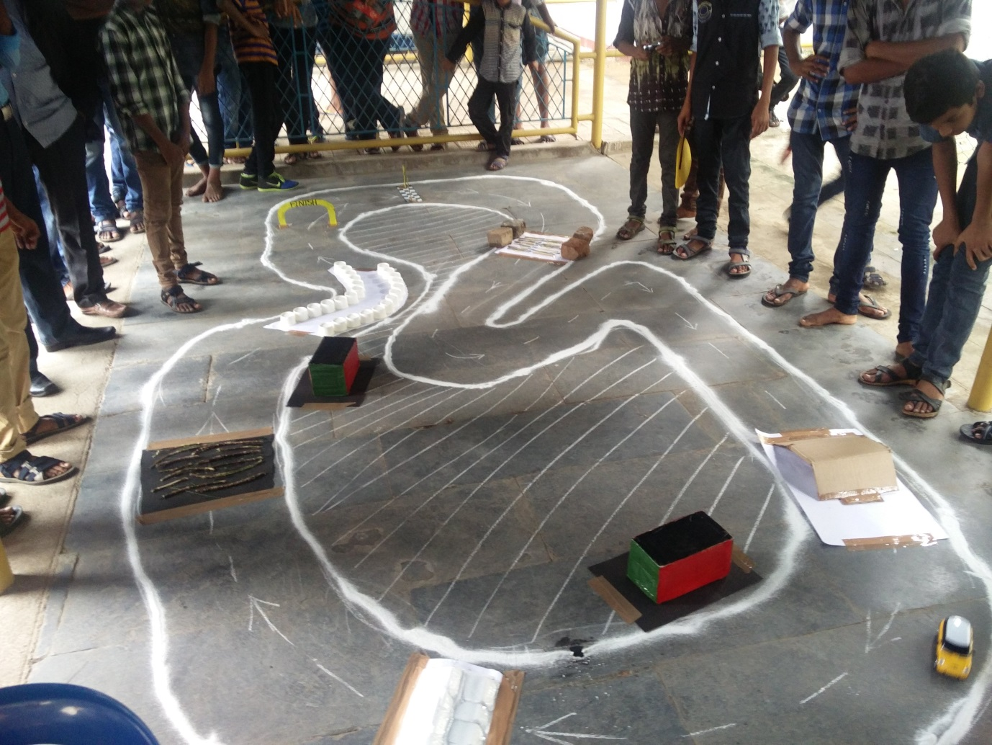

The obstacles as shown in the above picture were built using sticks and paper cups to lessen the damage to the car. There were elevated bridges which were difficult to cross and a service station was placed after two obstacles to create a realistic model.

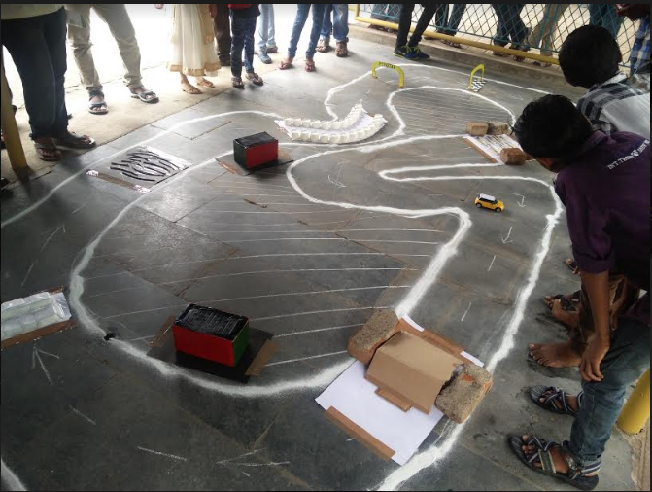

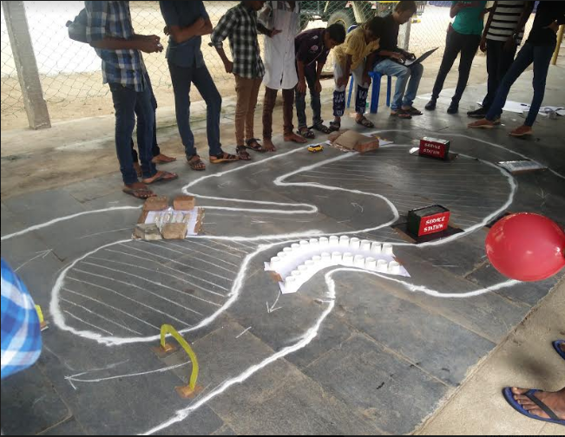

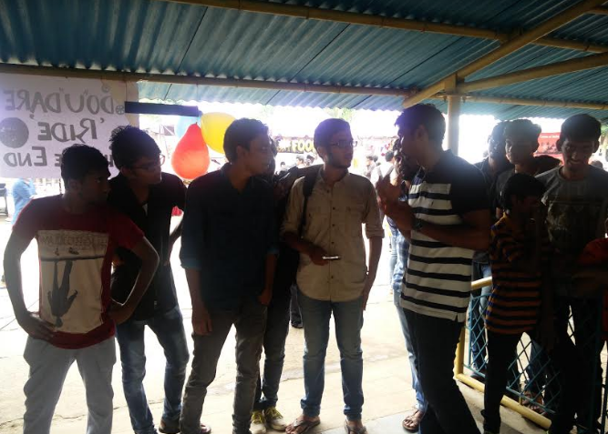

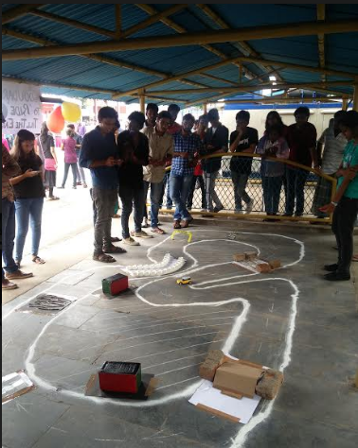

|  |  |  |  |  |  |  |  |  |
| --- | --- | --- | --- | --- | --- | --- | --- | --- |
|  |  |  |  |  |  |  |  |  |

## DATA COLLECTION:

The data collected is presented in the excel file below amounting to a total of 161 responses.



# ANALYSIS:

## 2 SAMPLE T-TESTS

## HYPOTHESIS 1:

Ho: There is no relationship between people liking towards the mode of scheduling an appointment and where people usually get their vehicle serviced

H1: There is a relationship between people liking towards the mode of scheduling an appointment and where people usually get their vehicle serviced

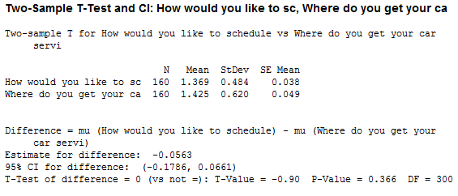

The test value shows that there is no relationship between people liking towards the mode of scheduling an appointment and where people usually get their vehicle serviced.

## HYPOTHESIS 2:

Ho: There is no relationship between the expectations out of a service and where people usually get their car serviced.

H1: There is a relationship between the expectations out of a service and where people usually get their car serviced.

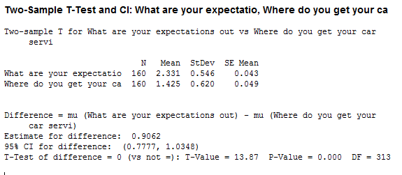

The test value shows that there is a relationship between the expectations out of a service and where people usually get their car serviced.

# SUMMARY:

A summary of the responses can be seen below:

The respondents were mostly from Chennai and Bangalore. Other places that the respondants originated from are Andhra, Bengal, Delhi, Haryana and Kerala.

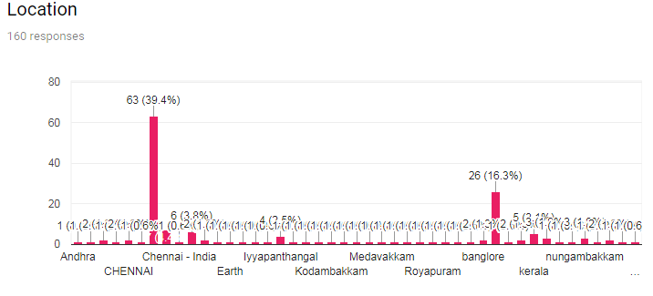

The respondents were majorly men.

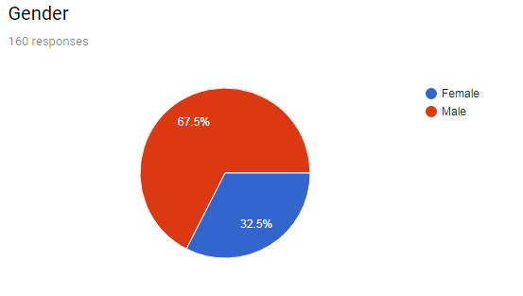

It could be seen that a lot of people preferred to schedule an appointment through a phone call and a good amount of people preferred an application while none of the respondents preferred a text message.

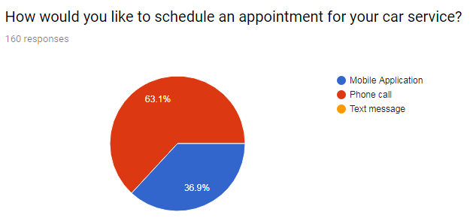

A majority of the people thought service quality would matter the most in their car service however they were considerably worried about the time taken for service and their convenience.

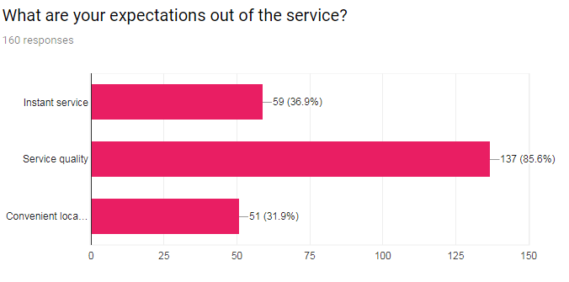

A majority of the respondents relied on the company service centre for their regular services.

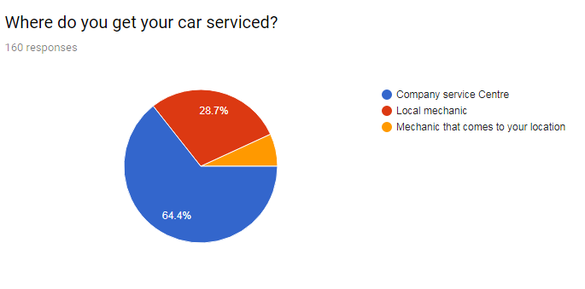

The data reveals that people either got their car service once in three months or once in every six months.

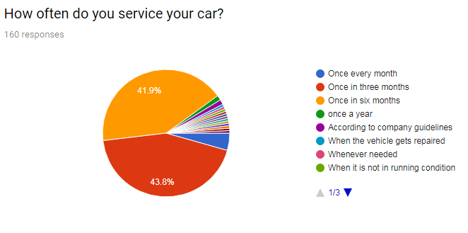

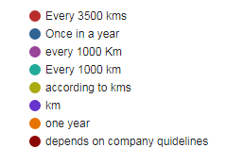

A majority of the people complained that they did not get a quick service.

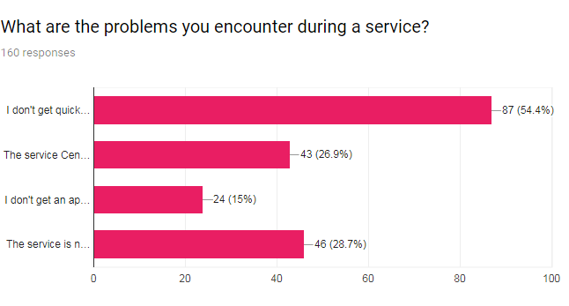

The price you would like to pay for an app based service:

1000 (50)

2000 (17)

50 (8)

500 (8)

60 (7)

100 (6)

3000 (5)

1500 (5)

NA (3)

300 (3)

800 (2)

40 (2)

70 (2)

A considerable amount if it seems efficient.

250

800 Rupees

₹750 for general service including water wash

It would be nice if that is possible. Time will get saved. It would be good to pay less through an app based service than the normal service system.

Less than 2500

An extra ₹150

Depends upon the service they offer

The same amount I am paying now

The exact amount i pay to the service centre.

10000 for each service

Only as much as I spend on the phone call.

Depends on the service required, around 5000

That'd be great and personally I would be comfortable as I could do my work and not waste time on taking my vehicle to the service centre.

Nil

Anything cheaper

Since it is an app based one, wish to get some exciting offers once a while . Would like to pay it directly to the mechanic who comes home.

1900

5000

As long as the service is good I'm willing to pay

Based on the problem

500 extra

10 Aed max

4000

Same as now

Free first service

Varies

50 INR

500 - 1000

Yes let me know the details

Best thing if no difference in normal service cost

Depends on the worth

450

10,000

Rs. 2000-3000

Since I’m not the person who pays I’m not aware. But a quality service can be paid well.

4k

500 to 1000 based on the service and repair

2300

100

Depends

150

# CONCLUSION:

* Since a majority of youths seem to make their own decision of car service and executes the process, it would be wise to target them initially for promotions.
* A good amount of people would prefer to book their service through mobile application since the youth these days are tech savvy enough it would be ideal for “MyTVS” to penetrate with its model.
* A large amount of people rely on phone calls for quick communication and hence a call for confirmation on the service and requisition for pre service details would leave a good impression.
* Majority of the people expect good quality of service and hence a quality service combined with convenience at doorstep will be largely appreciated by the youths.
* A good amount of people also want instant service apart from quality and hence these factors could contribute to customer retention.
* A majority of the youths believe the company service centre is credible, hence a good brand image that TVS already has can convert these customers to using the TVS service by initial promotional offers and by proving the brand’s credibility through professional service.
* Around 30% respondents seem to prefer local mechanic who could be attracted through reliable service quality and value for money pricing.
* There seems to be an association between offers and a mobile application which has to carefully dealt through profitable promotions.
* A customer friendly and a quick service seem to attract the youth on a large scale.
* A good amount of people also think they do not easily get an appointment for service and the service location being far away from the place that they reside in. These are two pain points that TVS can easily address and hence fulfil their need.
* A value for money pricing would be the way forward for TVS.